Types of storage in azure

Microsoft Azure provides a variety of storage services to meet the needs of modern applications. These services allow organizations to store and manage different kinds of data — such as unstructured files, structured databases, messages, and shared files — in a secure, scalable, and cost-effective way.

The main storage options offered in **Azure Storage Account** are:

1. **Blob Storage**
2. **File Storage**
3. **Table Storage**
4. **Queue Storage**

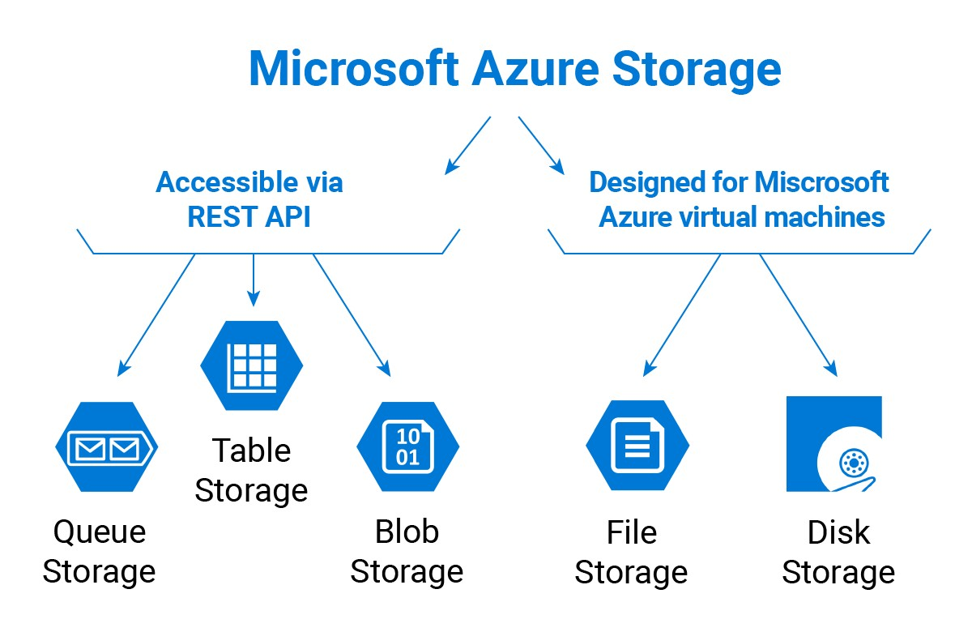

# Azure Blob Storage

Blob (Binary Large Object) storage is designed for **storing large amounts of unstructured data** such as text, images, videos, documents, backups, and logs.

**Key Points**

* Stores unstructured data (data without a fixed format).
* Highly scalable for storing massive amounts of data.
* Accessed over HTTP/HTTPS using REST APIs, SDKs, or Azure portal.
* Supports different types of blobs:
  + **Block blobs** – Store files like documents, images, videos.
  + **Append blobs** – Optimized for logs where data is added continuously.
  + **Page blobs** – Used for virtual hard disks (VM storage).

**Example**

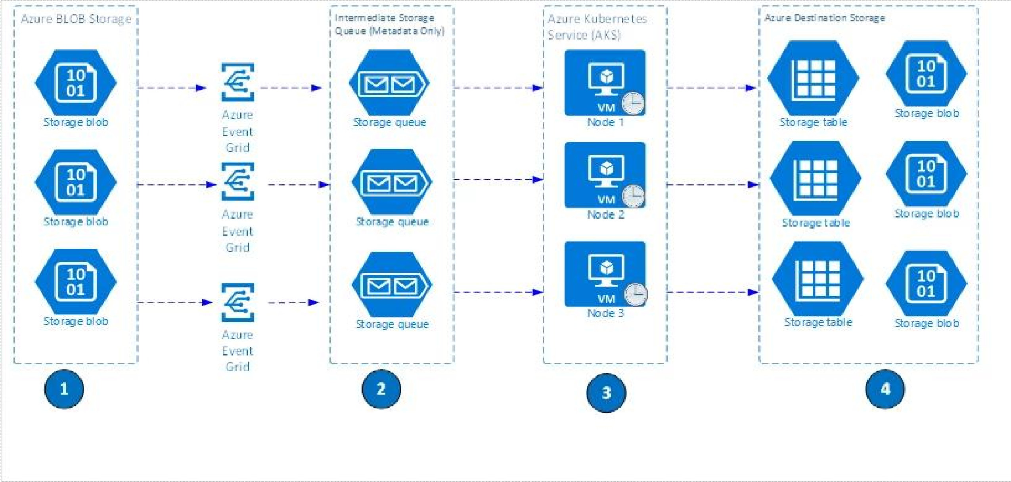An e-commerce company stores product images, user-uploaded photos, and video demos in **Azure Blob Storage** for easy global access.

# Azure File Storage

Azure File Storage provides **fully managed file shares in the cloud** that can be accessed using the Server Message Block (SMB) protocol. It is similar to a traditional file server, but hosted on Azure.

**Key Points**

* Stores files in a hierarchical structure (folders, directories).
* Can be mounted directly on Windows, Linux, and macOS systems.
* Supports SMB protocol, so apps and VMs can use it like a normal file share.
* Good for replacing on-premises file servers with a cloud-based alternative.

**Example**

A company migrates its shared documents (used by employees across offices) to **Azure File Storage**, so employees can access them from anywhere without maintaining local file servers.

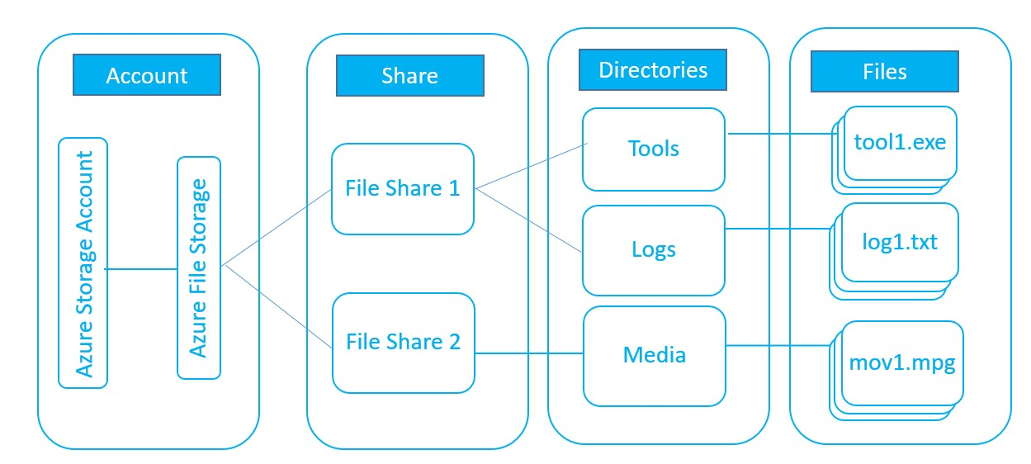

# Azure Table Storage

Table Storage is a **NoSQL key-value store** for structured but non-relational data. It allows storing data in rows and columns but without relationships like in SQL databases.

**Key Points**

* Schema-less: flexible structure (each row can have different properties).
* Stores massive amounts of structured data at a low cost.
* Data is indexed by **Partition Key** and **Row Key**, enabling fast lookups.
* Ideal for scenarios where you need quick access to large datasets without complex joins or queries.

**Example**

An IoT application stores sensor reading (device ID, timestamp, value) in **Azure Table Storage** for quick access and analytics.

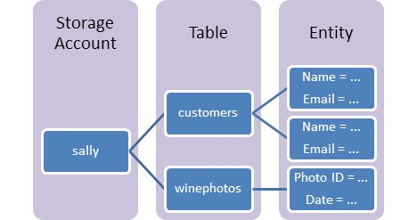

# Azure Queue Storage

Queue Storage provides **message queuing for communication between application components**. It enables decoupled and scalable distributed systems.

**Key Points**

* Stores messages (up to 64 KB each) in a queue.
* Used for asynchronous communication between services.
* Supports millions of messages in a queue.
* Reliable and durable – messages stay in the queue until processed.

**Example**

An online shopping app places customer order details in **Azure Queue Storage**. A background service then processes these orders one by one, ensuring smooth handling even when many users order at the same time.



# Conclusion

Azure offers different storage types to handle different needs:

* **Blob Storage** → Best for unstructured data like images, videos, documents.
* **File Storage** → Best for file sharing across machines and applications.
* **Table Storage** → Best for storing structured but non-relational (NoSQL) data.
* **Queue Storage** → Best for message passing and decoupling between application components.

By choosing the right storage type, organizations can optimize performance, scalability, and cost for their applications.

## Azure Storage Types Comparison

|  |  |  |  |  |
| --- | --- | --- | --- | --- |
| **Storage Type** | **What it Stores** | **Best For** | **Think of it as** | **Example Use Case** |
| **Blob Storage** | Unstructured data (images, videos, documents, backups) | Storing large files and media | Online hard disk | Store product images, app logs, videos |
| **File**  **Storage** | Files & folders, hierarchical structure | Shared file access across systems | Cloud file server / shared drive | Team documents accessible by all employees |
| **Table Storage** | Structured, NoSQL keyvalue data | Simple, scalable databases | Cloud-based Excel sheet | IoT sensor data (device ID, timestamp, value) |
| **Queue**  **Storage** | Messages (up to 64 KB) | Communication between app components | Waiting line of tasks | Online store orders queued for processing |

👉 **Quick Memory Hack**:

* **Blob = Big files**
* **File = Shared folders**
* **Table = Key-value data**
* **Queue = Message line**

### In simple terms,

1. **Azure Blob Storage** 
   * **What it is**: Stores large unstructured data like files, images, and videos.
   * **Think of it as**: A big online hard disk.
   * **Example**: Storing product images, user documents, or app logs.

1. **Azure File Storage** 
   * **What it is**: Cloud-based file shares that work like normal folders on your computer.
   * **Think of it as**: A shared drive, but hosted in Azure.
   * **Example**: Employees in different locations accessing the same shared documents.

1. **Azure Table Storage** 
   * **What it is**: A NoSQL database for storing structured data (rows & columns) but without relationships.
   * **Think of it as**: A simple, flexible Excel sheet in the cloud.
   * **Example**: Saving IoT device readings like device ID, time, and value.

1. **Azure Queue Storage** 
   * **What it is**: A message queue that stores tasks or messages between apps.
   * **Think of it as**: A waiting line where requests stay until processed.
   * **Example**: An online shop puts orders in a queue, and a worker app processes them one by one.